**ALGORITHM FOR DYNAMIC IMPLEMENTATION OF FCFS SCHEDULING**

1. CPU Scheduling algorithms are used for scheduling different processes present in the ready queue with available resources (CPU cores) in an optimal way so that each and every process gets executed by CPU.
2. Scheduling algorithms are broadly classified into two main types namely :



Preemptive Non-preemptive

1. First Come First Serve is an Non-preemptive Scheduling algorithm where each process is executed according to its arrival time.
2. First Come First Serve (FCFS) is also known as First In First Out (FIFO) scheduling algorithm is the easiest and simplest CPU scheduling algorithm where the process which arrives first in the ready queue is executed first by the CPU. New process is executed only when the current process is executed fully by the CPU.

Now before we get to the algorithm for FCFS scheduling , we first look at the following terms to see what they mean and why do we need them in our scheduling process :

* BURST TIME : The total amount of time required by the CPU to execute the whole process is called the Burst Time.
* ARRIVAL TIME : the time when a process enters into the ready state and is ready for its execution.
* FINISH / COMPLETION TIME : The Time at which the process enters into the completion state or the time at which the process completes its execution
* WAITING TIME : How much time processes spend in the ready queue waiting their turn to get on the CPU.
* TURN AROUND TIME : the time taken by a process since it enters a ready queue for the process of execution till the completion.

The **ALGORITHM** for the first come first serve CPU scheduling is as follows :

**Step 1.** Input the number of processes required to be scheduled using FCFS, burst time for each process and its arrival time.

**Step 2**. Using enhanced bubble sort technique, sort the all given processes in ascending order according to arrival time in a ready queue.

**Step 3.** Calculate the Finish Time, Turn Around Time and Waiting Time for each process which in turn help to calculate Average Waiting Time and Average Turnaround Time required by CPU to schedule a given set of processes using FCFS.

* Step 3.1 : for i = 0, Finish Time T 0 = Arrival Time T 0 + Burst Time T 0
* Step 3.2 : for i >= 1, Finish Time T i = Burst Time T i + Finish Time T i - 1
* Step 3.3 : for i = 0, Turn Around Time T 0 = Finish Time T 0 - Arrival Time T 0
* Step 3.4 : for i >= 1, Turn Around Time T i = Finish Time T i - Arrival Time T i
* Step 3.5 : for i = 0, Waiting Time T 0 = Turn Around Time T 0 - Burst Time T 0
* Step 3.6 : for i >= 1, Waiting Time T i = Turn Around Time T i - Burst Time T i – 1

**Step 4.** Process with less arrival time comes first and gets scheduled first by the CPU.

**Step 5.** Calculate the Average Waiting Time and Average Turnaround Time.

**Step 6.** Stop .

**IMPLEMENTATION EXPLANATION**

Let’s understand the implementation with the help of an example given below :

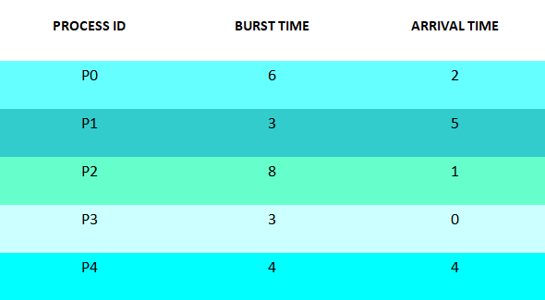

**Step 1** : Processes get executed according to their arrival time.

**Step 2** : Following shows the scheduling and execution of processes.

* **Step 2.1** : At start P3 arrives and get executed because its arrival time is 0. Its duration of execution is 0-3 seconds.

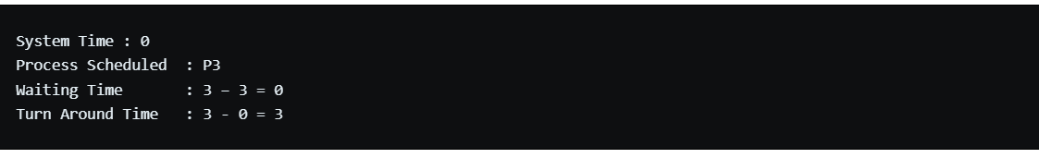

* **Step 2.2** : P2 arrives at time 1 sec during which CPU was busy with Process P3.After completion of P3 , P2 is executed for duration 3-11 seconds.

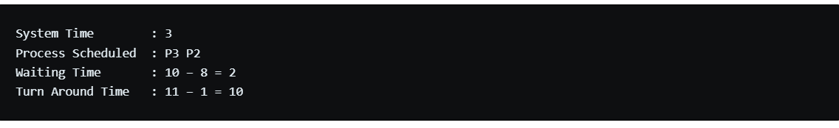

* **Step 2.3** : P0 arrives at time 2 sec but its execution is started at 11 sec after complete execution of process P2 , for a duration 11-17 seconds.

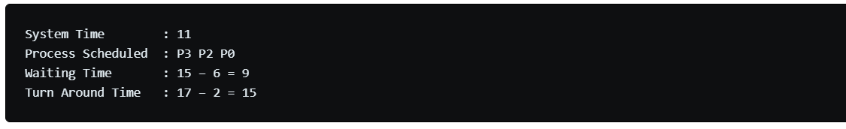

* **Step 2.4** : P4 arrives at time 4 sec but gets resources of CPU at 17th second for execution. Its execution period is 17-21 seconds.

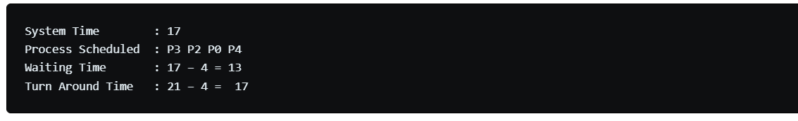

* **Step 2.5** : Similarly P1 arrives at time 5 sec but its execution gets started at time 21st second and lasts for a period 21-24 seconds.

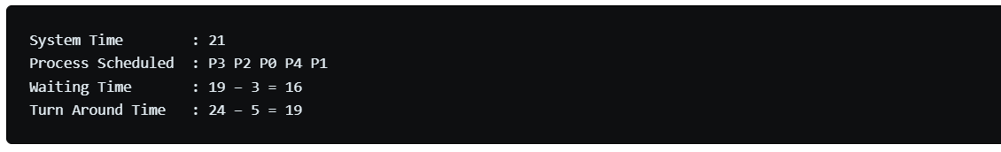

* **Step 3** : After scheduling of all provided processes :

